

De-stress service application

Project Report



[Date]

[Company name]

[Company address]

Contents

1. Introduction 1

1.1. Introduction 1

1.2. Existing System 2

1.3. Need for The New System 6

1.4. Objective of The New System 7

1.5. Problem Definition 8

1.6. Software Process Model 9

1.7. Core Components 10

1.8. Project Profile 11

1.9. Advantages and Limitations of the Proposed System 12

2. Requirement Determination & Analysis 12

2.1. Requirement Determination 13

2.1.1. Functional Requirements 13

2.1.2. Non-Functional Requirements 14

2.1.3. Hardware Requirements 15

2.1.4. Software Requirements 16

2.2. Targeted User 17

3. Feasibility Study 18

3.1. Technical Study 18

3.2. Timeline Chart 19

3.3. Economic Study 20

4. System Design 21

4.1. Use Case Diagram 21

4.2. Class Diagram 22

4.3. Sequence Diagram 23

4.4. Activity Diagram 24

4.5. Data Dictionary 25

4.6. Algorithm Flow 26

5. Canvas 27

5.1. Empathy Mapping Canvas 27

5.2. AEIOU Canvas 28

5.3. Ideation Canvas 29

5.4. Product Development Canvas 30

6. Development 31

6.1. Coding Standards 31

6.2. User Interface 32

7. Future Enhancement 33

8. Plagiarism Report 34

9. Conclusion 35

10. References 36

# Introduction

## Introduction

With personal and social issues on the rise today, we are trying to help the community with solutions for depression. Stress and other mental disorders are issues we fail to see. It affects about 450 million or one out of every four people around the world. Mental illness and stress management continue to be some issues young adults strive to resolve.

Handling stress is the key to solve this issue. The lack of understanding and acknowledgement about symptoms varies as lifestyle changes.

We are creating a platform where a user can visit and search for answers or solutions for their concern. The user can interact with others with the same problem, ask their opinions and even directly fetch the solution from one who had similar problems long ago. We are targeting the generation of teenagers and Millennials as their problems are solvable and our country is the youngest in the world. By removing their worries, we are creating a stable India.

We hope that our services will be useful and inspiring to others.

## Existing System

7cups.com

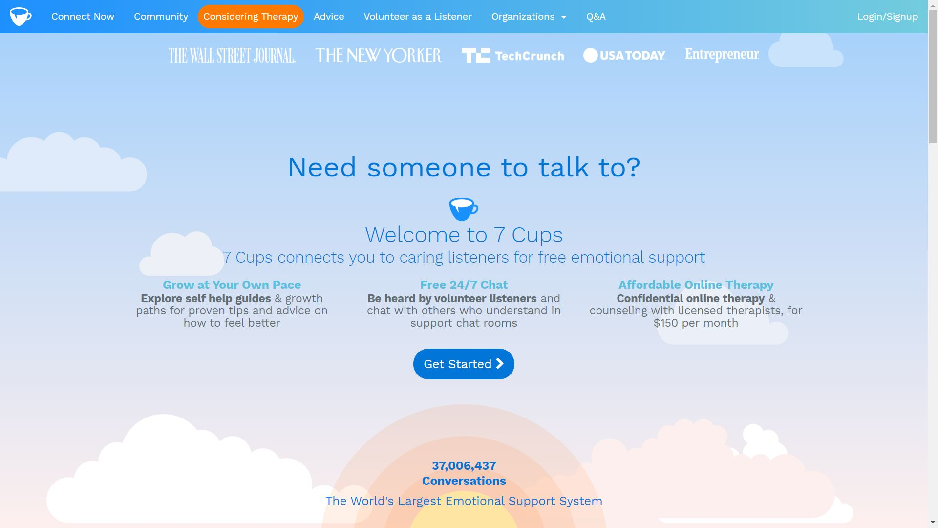

talkspace.com

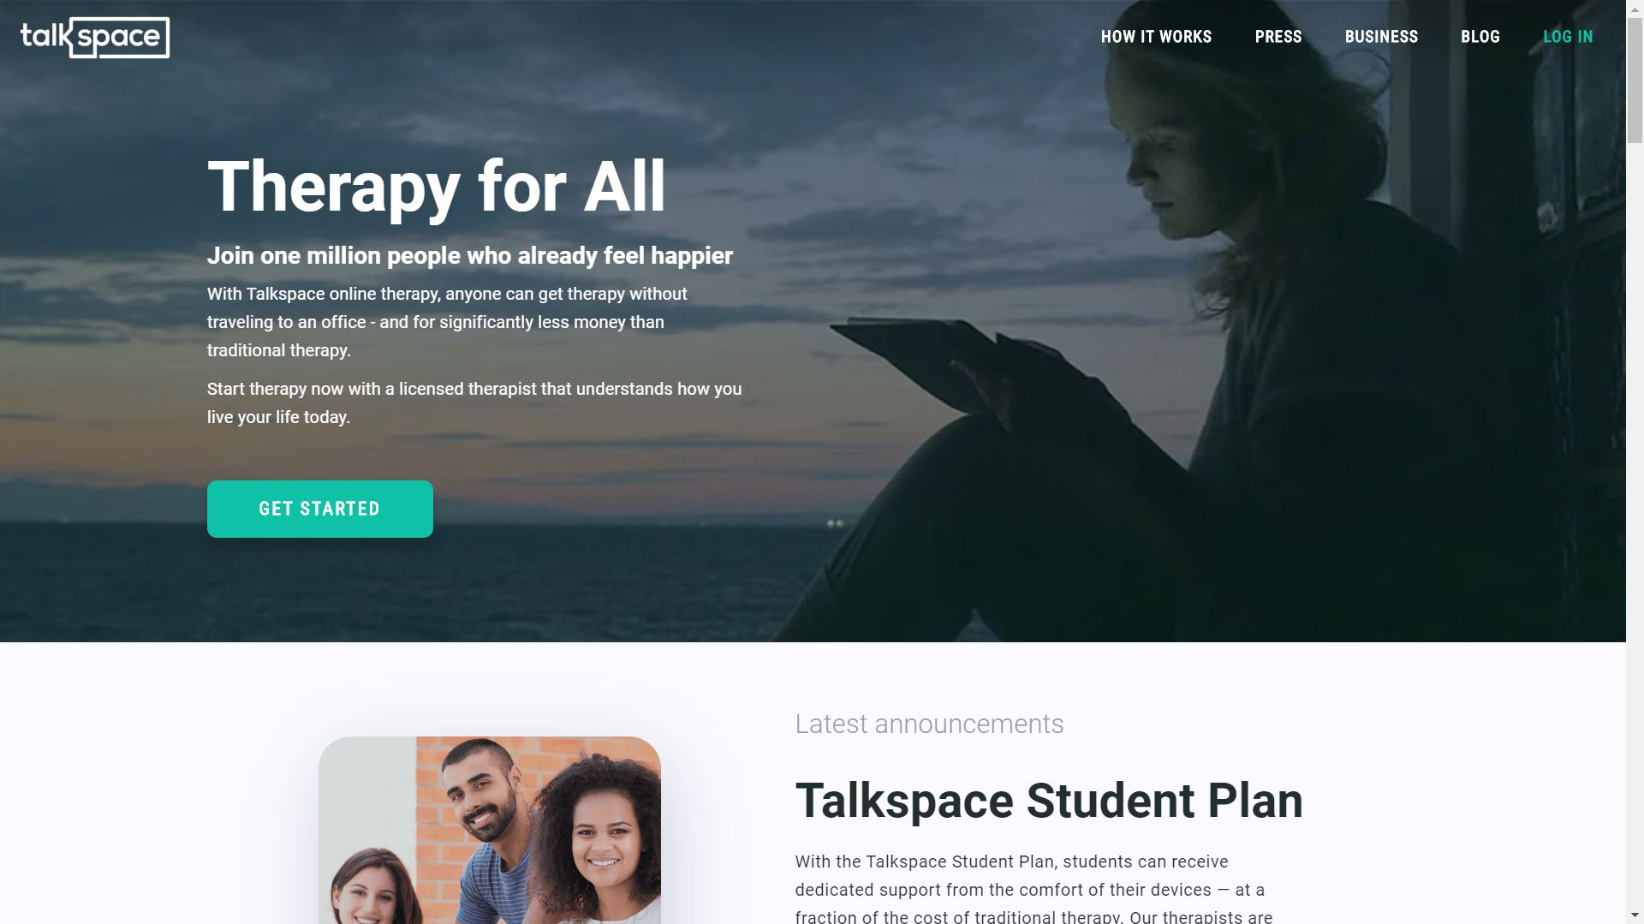

sibly.co

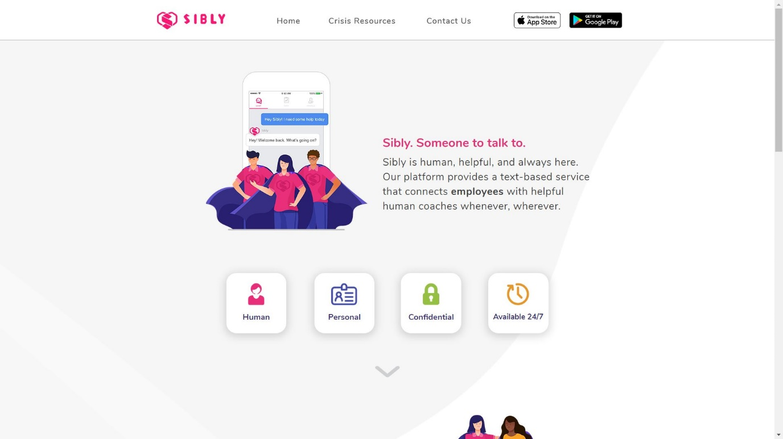

betterhelp.com

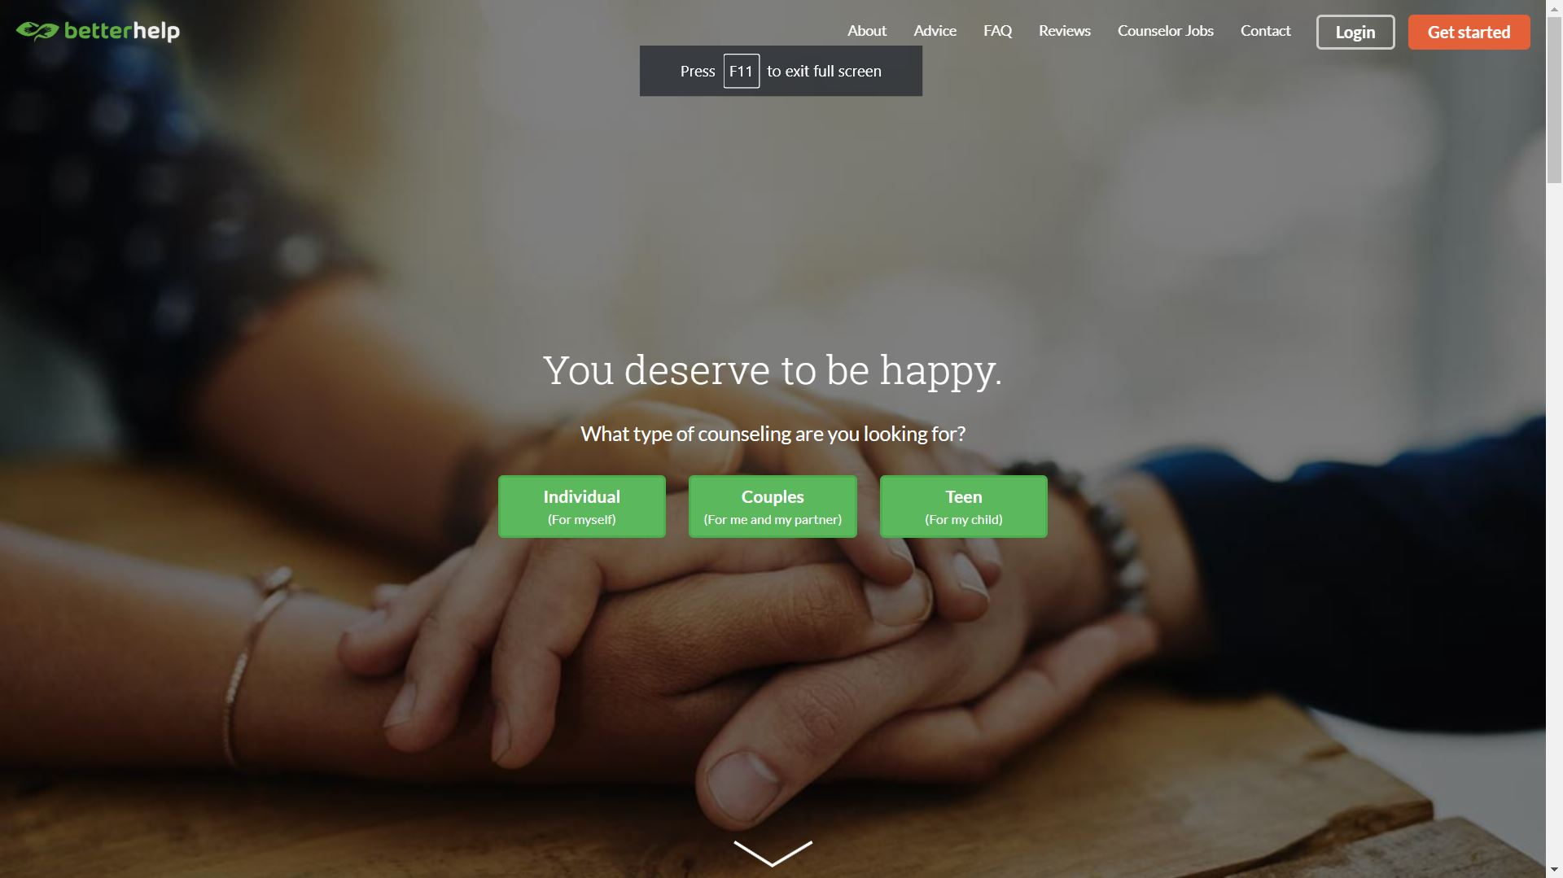

ginger.io

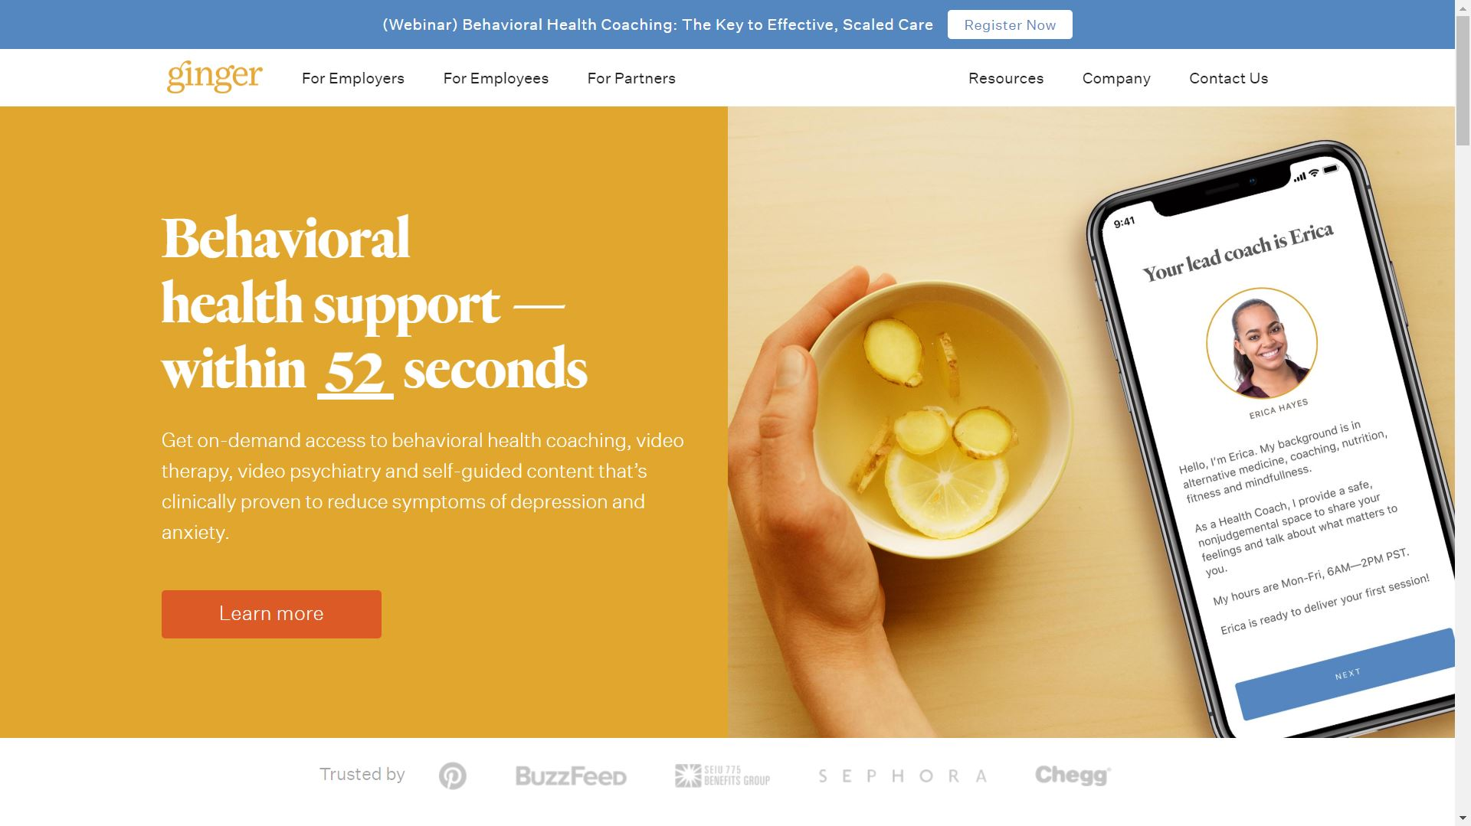

woebot.io

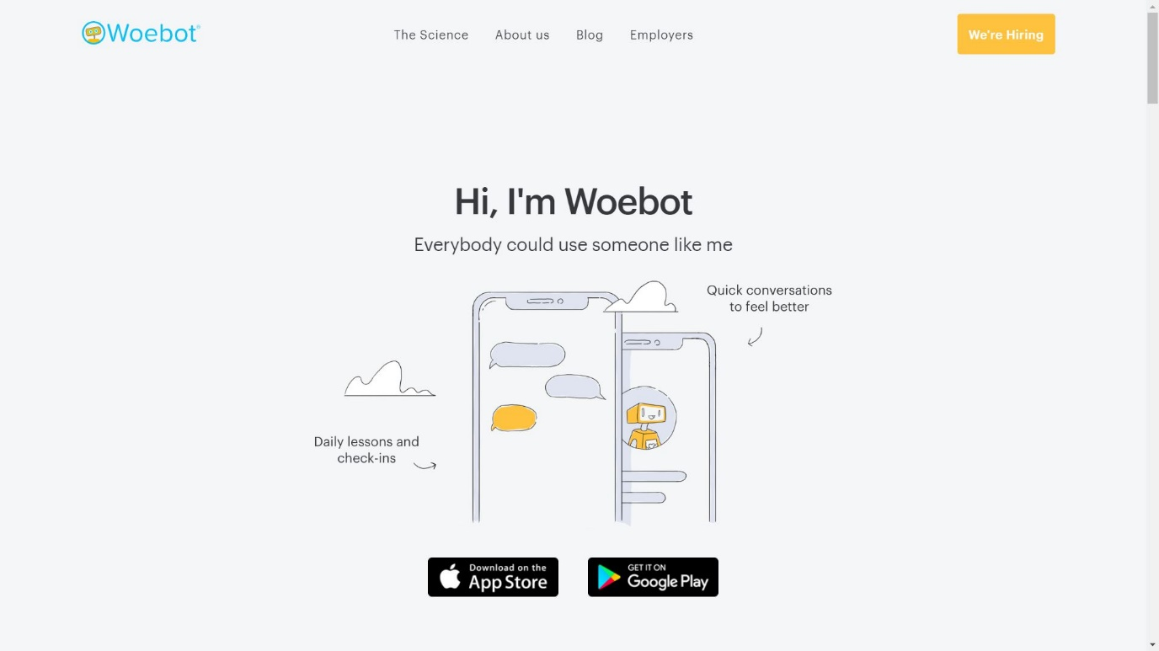

iprevail.com

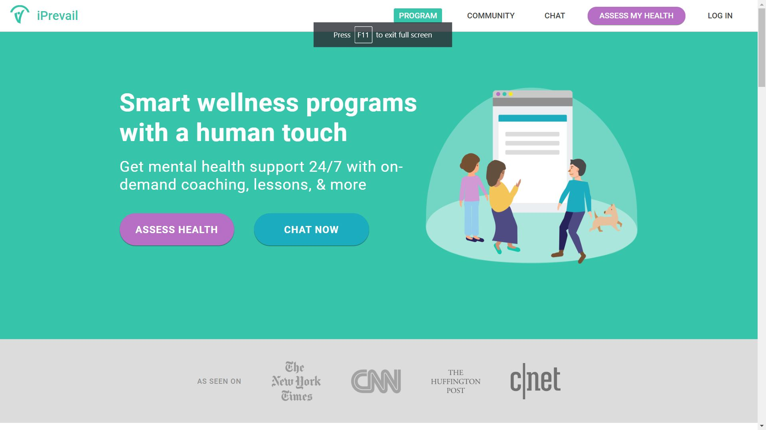

golantern.com

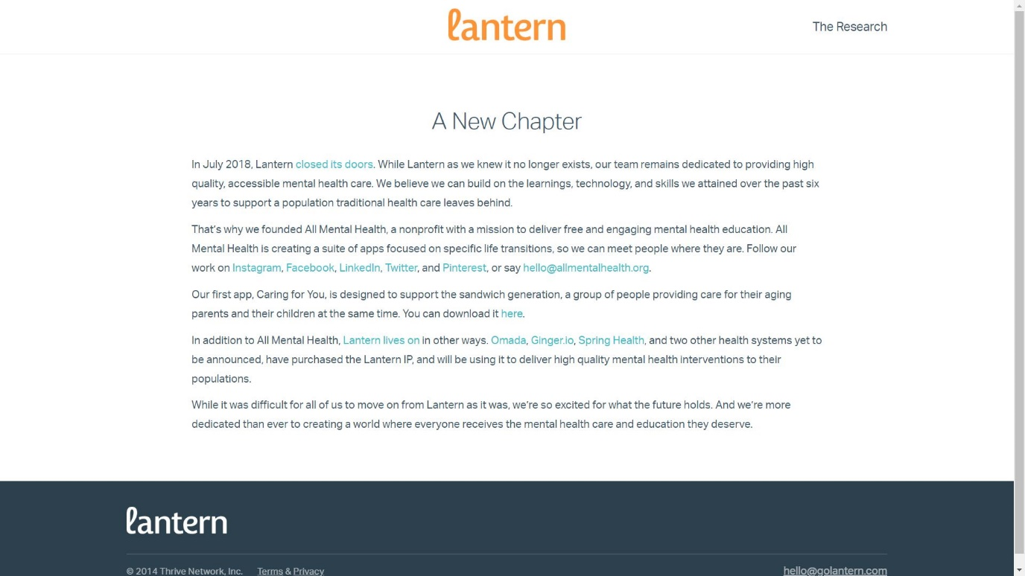

## Need for The New System

Poorly Designed Websites.

Any website’s primary goal is that the user should be able to navigate the page easily. But these websites are not so easy to navigate. The looks and feel of any website should reflect its motive and mood to the users. Some of the sites are not using the correct colour scheme like using dark colours which represent sadness instead of bright colours which reflect happiness.

Less Skillful volunteers.

There are some cases where the volunteer is not been able to understand the user or even left in between the conversation without any notice, the user is stuck in this situation and can get frustrated. The selection of volunteers should be maintained with proper guidelines and qualifications.

Availability on different platforms.

Some sites like woebot.io are only available on App Store and Google Play. Some users might not be able to use these services because of that.

## The objective of The New System

Easy to understand and navigate.

Proper design should be implemented so that the user is not wasting time in navigating the site. Proper colour coding should be done on each and every element of the web page.

Experienced Listeners.

There should be some minimum qualifications or criteria for a person to be able to volunteer on these websites.

Active Community.

Apart from the volunteers, the users should maintain good practices of conducting various games or challenges online to create a healthy atmosphere for the users.

Cross Platform.

These services should be available on all possible platforms.

## Problem Definition

We want all the people specially the teenagers to live a depression free life where everyone is aware and able to overcome their problems related to mental health.

Today we have too many cases of these young generation not been able to cop up with the world only because of lack of emotional support. The parents and close ones are not able to recognize and help these children. We may miss the opportunity to become a fully developed country and can result in a world where no person is happy and had no driving force to move forward in life. These children are the future work force of the country.

We will help these children by giving them mental support like therapies and teach them how to face depression and improve thinking capabilities.

## Software Process Model

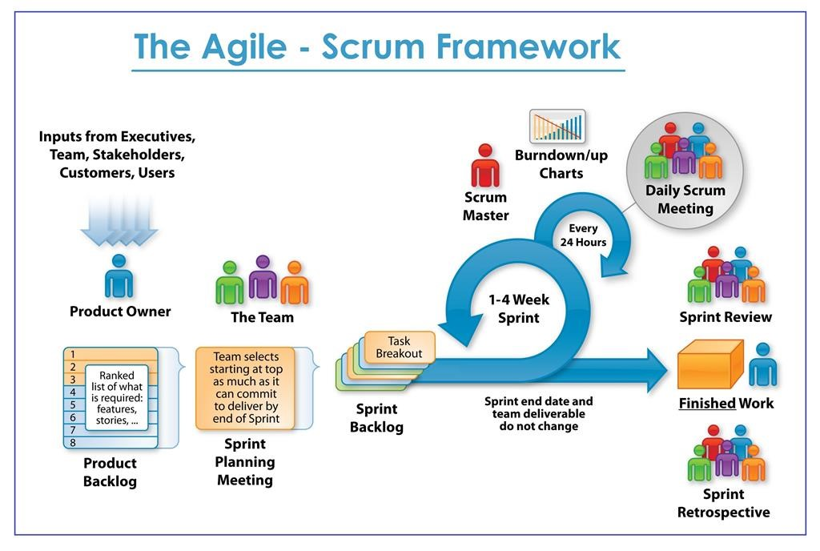

## Core Components

Node.js

React

MongoDB

Microsoft LUIS NLP

Microsoft Azure

Heroku

## Project Profile

Introduction

Chatbot Working

Socket Chat

### Introduction

Chatbots are being made to ease the pain that the industries are facing today. The purpose of chatbots is to support and scale business teams in their relations with customers. It could line in any major chat applications like Facebook Messenger, Slack, Telegram, Text Messages, etc.

Chatbots may sound like a futuristic notion, but according t global web nidex statistics, it is said that 75% of t=internet users are adopting one or more messenger platforms. Although research shows us that each user makes use of an average of 24 apps a month, whesein 80% of the time would be in just 5 apps. Undoubtedly among them are Fa

### Chatbot Working

### Socket Chat

## Advantages and Limitations of the Proposed System

Advantages

The system is available on 3 platforms Google Play Store, Apple App Store and a Website.

The system is designed for easy navigation.

Colour scheme will be provided to the user as a choice.

Dis-advantages

The selection of volunteers is still not guaranteed to succeed in filtering the candidates.

Sone users may find this design not compactable with them.

# Requirement Determination & Analysis

## Requirement Determination

### Functional Requirements

User should be able to change the colour scheme anytime while using the service.

All the navigation options should be available to the user home page.

Navbar should be aligned to the left of the screen on the website.

Navbar should be aligned to the to the top of the screen in case of mobile application.

User should be able to select the type of query while giving a feedback.

Mobile application should be light weight and should not consume great amount of resources.

Website should not heavily rely on JavaScript as it may lead to slower loading of pages.

Only administrators are able to view the Database.

### Non-Functional Requirements

The website should be capable to handle more than 1000 users with affecting its performance.

User should be able to flag a volunteer and even vice versa when the conversation becomes inappropriate.

User should be able to get to speak with a volunteer within 2 minutes of the request.

### Hardware Requirements

A laptop or any computing device with a screen where the admins are able to monitor the websites and its functionalities.

### Software Requirements

Node.js

React

Microsoft LUIS

Heroku

Microsoft Azure

MongoDB

Visual Studio Code

TensorFlow

Browser

## Targeted User

Children (8 – 14 years)

Youth (15 – 24 years)

# Feasibility Study

## Technical Study

## Timeline Chart

## Economic Study

# System Design

## Use Case Diagram

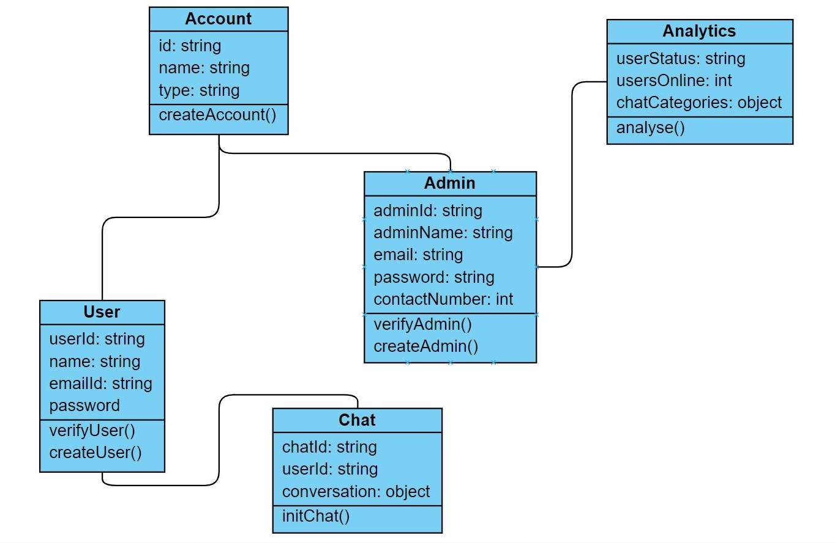

## Class Diagram

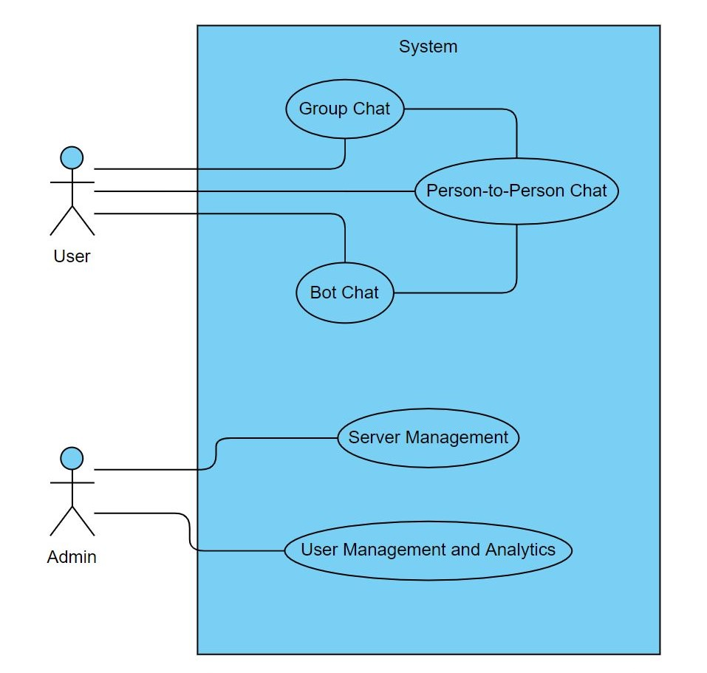

## Sequence Diagram

## Activity Diagram

## Data Dictionary

## Algorithm Flow

# Canvas

## Empathy Mapping Canvas

## AEIOU Canvas

## Ideation Canvas

## Product Development Canvas

# Development

## Coding Standards

## User Interface

# Future Enhancement

# Plagiarism Report

# Conclusion

# References

<https://www.snyxius.com/implement-agile-development-process-easy-steps/>